1. render a html file order.html and pass a variable "person_name", an array of order_list containg the item names, and a conditional flag "ordered_warranty" and display it.
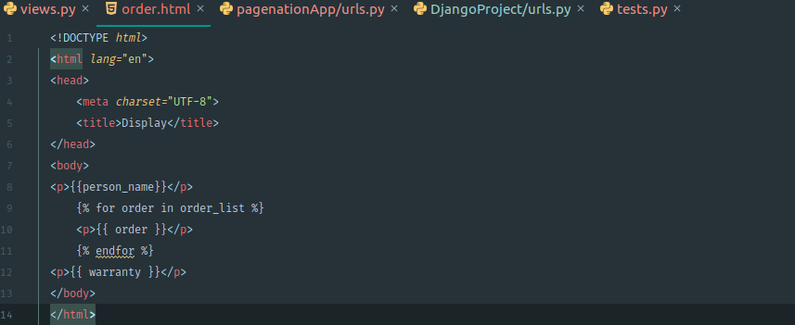
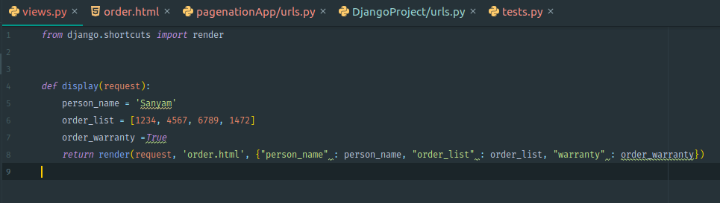
2. what is render() ?
Combines a given template with a given context dictionary and returns an HttpResponse object with that rendered text.Django basically uses this function to return a particular html page instead of calling a function in the views.py file and dynamically updates the content of a html file by not loading the whole page again.
Syntax : render(request, template_name, context=None, content_type=None, status=None, using=None)

3. difference between the tag {% include %}. and {% extends %}
{% extends %} : Signals that this template extends a parent template. It basially is a type of inheritance in which if we want to use a feature of the parent template we have to override it.
{% extends %} : Loads a template and renders it with the current context. The template it loads merges with the already present data in the current template and overriding is not needed.

6. What is Pagination ? create a list of 1000 integers then using this list apply pagination.
Pagination provides a functionality of dividing a given data in several pages with both Previous and Next links. It is helpful when a person has a lot of data to view and he wants it to be properly managed.

7. What is the variable BACKEND, DIRS, APP_DIRS, OPTIONS used for ?

BACKEND describes the Django backend API implementing templates
DIRS determine the locations for the templates folder for the project and different apps
APP_DIRS set true or false tells whether or not Django would look for templates inside the apps as well
OPTIONS is used to provide backend related settings

